Anglesey Adventure
The Race of Remembrance weekend started on Wednesday with the drive up the A5 and through some glorious scenery through Snowdonia National Park.
Upon arriving at Anglesey Circuit the process of unloading the two MX 5 MK1 race cars and all the required tools, spares etc. commenced. After two hours everything was sorted and the hospitality gazebo was set up. It was time to head for the team accommodation at Church Bay and a welcome meal, a beer and to meet other teams’ members before a reasonably early night.
Thursday dawned dry, but cold and windy. After final checks on the cars we proceeded to, in my case, to learn the circuit and get the feel of the car. There were no problems during the full day of testing and all four drivers of our car, 74, ended the day with competitive times. Sebastian Fisher was fastest with John Chambers and myself being about a second or so slower and Andy Balfor five seconds off the ultimate pace. As this was his first ever race his times were both smooth and consistent, just what the team needed for a ten hours race. After a long day, at 1600hrs, we adjourned back to our accommodation for food and drink and to plan tactics for the next day’s qualifying.
After some overnight rain, the dawn brought dry and windy conditions on Friday. Qualifying went well with our car 4th fastest out of 11 in class, but we had limited revs to 6500 to save the engine. We were happy to find no problems with the car other than a leaking front brake caliper which was soon changed by our sterling support team members.
Saturday dawned fine but windy again. With a later start than previous days, a relaxed breakfast was had by all team members prior to a few hours completing final checks and polishing the car before the 3 hours of night driving starting at 4pm.
The race started on the dot of 4pm with 40 cars going off after 2 pace laps. It made an impressive sight for the first few laps. With Seb Fisher driving the first session we kept pace with the leading cars in our class, but slowly dropped behind as they were pushing very hard and seemed to be treating it as a sprint race.

Apologies for missing this out from the last Newsletter. Val
September Drive 2016, Courtesy of Karen & Ian
The September Drive started from the Fox Inn, Broadwell, Near Stow-On-The-Wold (Karen & Ian’s local) a pleasant cool and crisp morning with blue sky and early sunshine. We all arrived to be met by our hosts, Karen and Ian who had arranged pre-drive Bacon & Sausage Baps with plenty of cups of tea. Having wrestled a monstrous Bacon Bap into submission we were ready for the day. I’m not sure though that we were ready for Dave G & Owain who (without the supervision of their ladies today) must have thought it was fancy dress and turned up as a couple of rodents! Dave also showed a selection of crazy hats that he had in his boot which reminded me of a Tommy Cooper sketch I once saw….Just like that!
Karen soon called us to order and twenty one MX5’s left the car park. The drive took us out of Broadwell Village and into the Gloucestershire and Oxfordshire countryside. This well planned route had something for everyone, fast ‘A’ and ‘B’ roads for the likes of Trevor ‘Hamilton’ & Gerard ‘Rosberg’ who like to ‘give it some beans’, I believe the expression is and picturesque Cotswold villages for those who like to ‘tootle’ along taking in the view (like the current Mrs H)
Everything was going well until the L and R that I wrote on the back of Junie’s hands with a biro wore off and we took a wrong turn. Isn’t it always comforting to see someone else when you’ve got it wrong? We bumped into Mal, Val & Jeff at Dancers Hill and tagged ourselves on the end. As our three cars all went the wrong way, Mal realising the mistake did a quick handbrake-turn with Jeff and us hard on his heels. Thanks to Mal and after a slight diversion, we had Bourton in our sights. Did anyone else see the Giraffe on the final approach into Bourton? Yes, a Giraffe!
As we approached our destination, it was clear that the sunshine had brought out the crowds and parking would be a challenge. Most of the group headed for the Coach Park and the Bourton Grand Prix began. The only incident in the car park Grand Prix was when someone said that Jeff had kissed Mal in the car park! (it turned out he’d kissed his bumper with his own) but no damage done thank goodness. After many laps of the car park we squeezed into a space made for a Dinky car and headed for the village centre where the group had set up their picnics.
Bourton is a picture postcard village with a river running through the centre. Most of us picnicked in the glorious sunshine by the riverside while some opted for a pub meal and a pint. Some of us visited the gift shops and Bourton also has a model village, super pubs, cafes and a great motor museum. The only thing to spoil the picnic was when John White crept up behind Jeff and took his little sausages from his lunch box, we won’t invite him again without Penny being there to keep control of him.
The day was over all too soon and we were on our way home. I’m certain we all had a great day with all the usual laughs and banter amongst friends. Many thanks to Karen & Ian for a great day and I remembered what Stuart posted on the forum following the Plum Festival, he said ……”This club gets better and better”………He’s right!
Vince and Co-Pilot Junie.
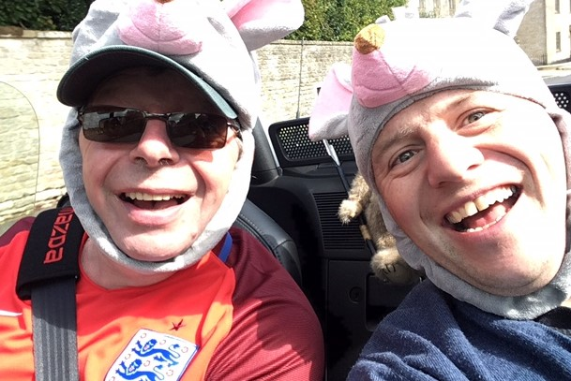

Calendar of Events 2017
 | Monthly Meeting | Monthly Drive | Other Events
February 2017 | 2nd Royal Oak Much Marcle | 19th Vince and June
March 2017 | 2nd March Gups Hill Manor | 19th Vacant
April 2017 | 6th Pear Tree Smite | 30th Owain and Karen | 23rd Spring Rally Ashton Court Bristol
May 2017 | 4th Royal Oak Much Marcle | 21st Vince and June  Blossom Trail
June 2017 | 1st Gups Hill Manor | 18th Jake and Mike
July 2017 | 6th Pear Tree Smite | 23rd Dean and Jackie
August 2017 | 3rd Royal Oak Much Marcle | 20th Vacant | 28th Pershore Plum
September 2017 | 7th Gups Hill Manor | 17th David and Gavin MX-5 Giro Panoramico
October 2017 | 5th Pear Tree Smite | 22nd Jeff, Chris and Henry  Hartlebury Castle
November 2017 | 2nd Royal Oak Much Marcle | 19th Vacant
December 2017 | Christmas Lunch date tbc | No Drive
Area Coordinator: Mal Jones; 01684 560998; malfishing47@aol.com
Webmaster: Chris Wood; 01386 554409; 07902 279395; chriswood99@btinternet.com
Drives Coordinator: Vince Holley vinceholley@atlastraining.co.uk
Events Coordinator: Terry Manders: 07976099140 Tezzy1956@btinternet.com
Newsletter Editors: Val Sedge-Jones: 01684 560998; salvedge@aol.com
Sue Abel: 07808053556; sue.abel@btinternet.com
International : John White 07979 965619

