Using the area website and area forum

The area website can be found by typing http://swm.mx5oc.co.uk/ into your browser
or searching for swm mx5oc.

The Home page should look like this:

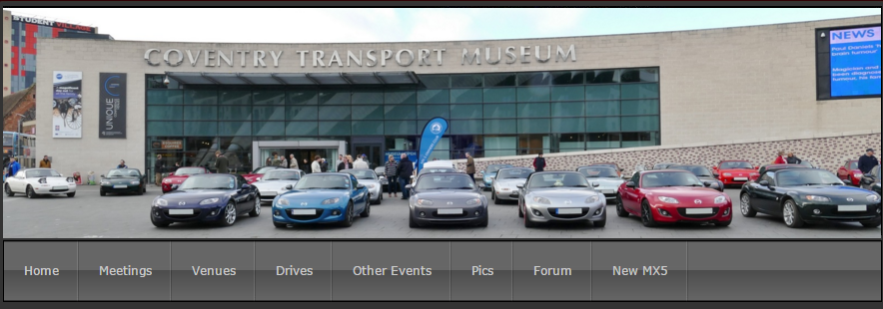

This is where you should go to find out what is going, where and when.
For example click on Meetings (as shown by the arrow) and you will be able to see where our monthly meetings are.

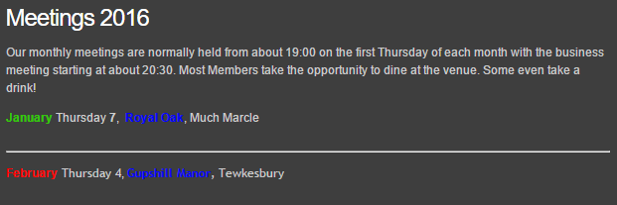

By clicking on the highlighted name of the pub you will be taken to Venues which has more details about how to find the pub. Also there will be a link to a map.

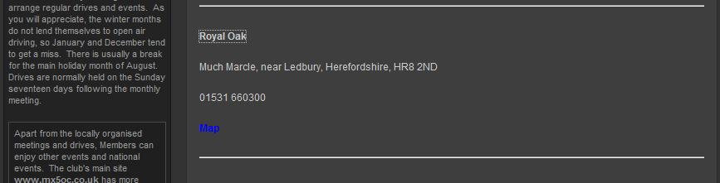

From any page you can also check out Drives, Other Events, Pics (a selection of photos), our area Forum and the New MX-5 (mark 4).

The area discussion Forum is where you might find more information about drives and other events such as people letting organisers know of their attendance or organisers giving up to date information about an event. It is also a place where you can air your views or ask about maintenance or even buy and sell cars.
The Forum can be accessed by clicking on the Forum tab on the any page of the website or by typing http://mx5ocswm.proboards.com/ into your browser.
Currently this is a closed forum and you need to be able to login. If this is your first time you will need to register then wait for a reply telling you how to activate your login once the administrator has approved the registration (usually the same day).
When you are into the forum it should look like this:

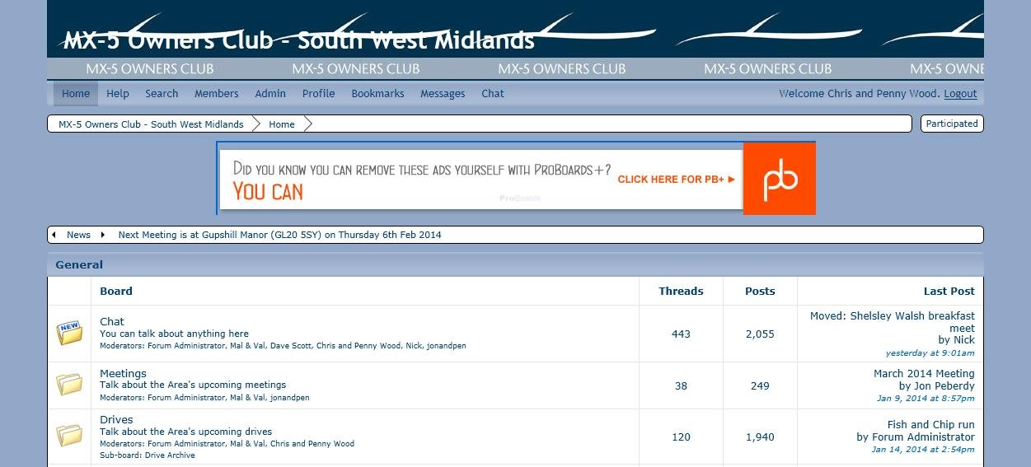

By clicking on a folder you can you can then see sub-folders:

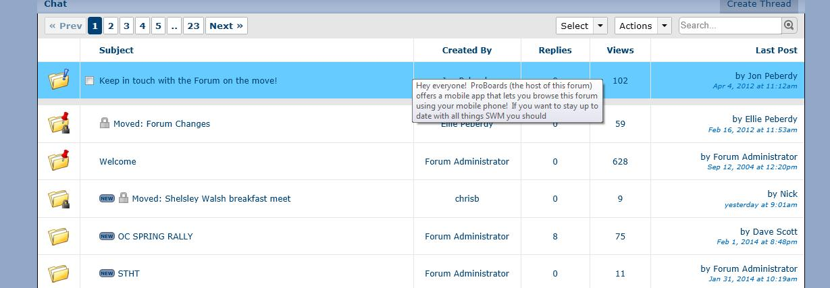

By clicking on a thread (sub- folder) you can then read people’s posts and add to them by clicking on reply:

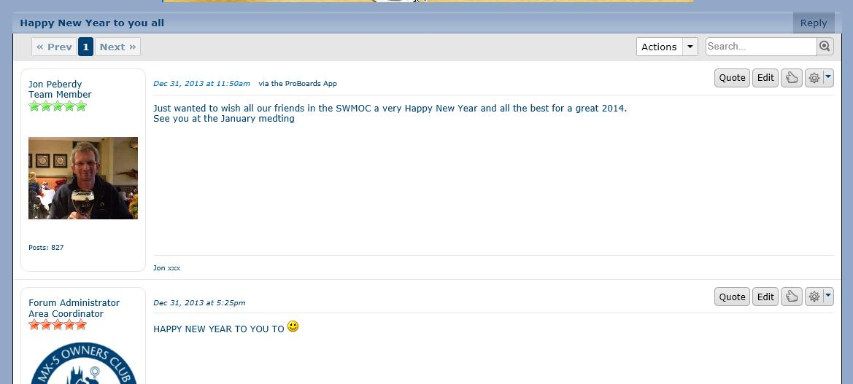

To start a new thread, go into the folder you most appropriate for your post, eg Drives:
Click on create thread

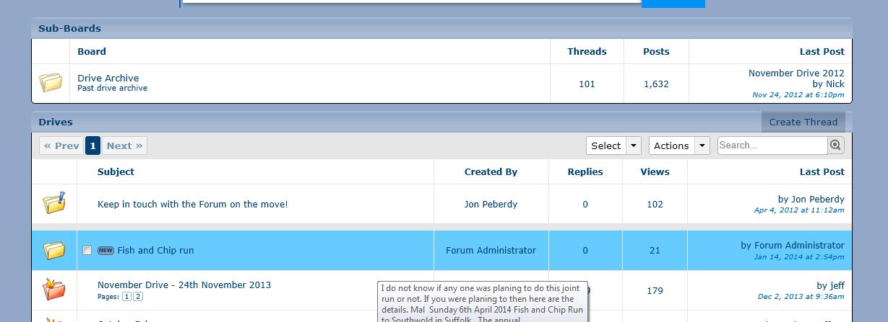

Give your new thread a subject and then away you go!

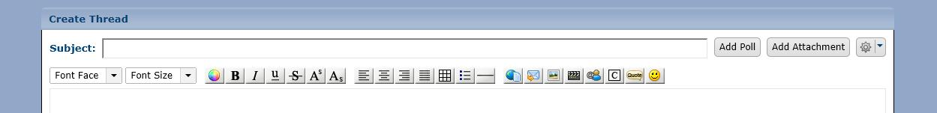

Of course the Owners Club has its own website https://www.mx5oc.co.uk/

and discussion forum https://www.mx5oc.co.uk/Forum/

