Wales & Wye: The Castle Canyon Cruise
Date: Sunday 19th May 2024
Start: The Woodshed, Deer Park, Eastnor, Ledbury HR8 1RA
Time: 9:00 for breakfast / coffee
Depart: 10:15 (10:30 latest)
Coffee / Lunch: The Copper Kettle Tea Room, Emm-lee, Llanddewi Skirrid, Abergavenny NP7 8AP
Finish: Symonds Yat Rock, Coleford GL16 7NZ

Miles | Direction |  | Instructions | Km
0.0 |  |  | Turn Right onto the A438 signed Ledbury | 0.0
1.1 |  |  | Turn Left onto Worcester Road (A449), signed Ledbury | 1.76
2.1 |  |  | Turn Left at Traffic lights. Follow signs for Through Traffic | 3.36
2.7 | 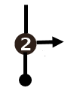 |  | At the roundabout, take the 2nd exit right to Hereford A438 | 4.32
3.0 | 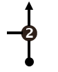 |  | At the roundabout, take the 2nd exit to Hereford | 4.8
3.3 |  |  | At the roundabout, take the 2nd exit to Hereford | 5.28
3.5 |  |  | At the roundabout, take the 1st exit to Dymock B4216 | 5.6
A 6.1 |  |  | Confusing signage. Carry on as normal. | 9.76
A 7.1 | 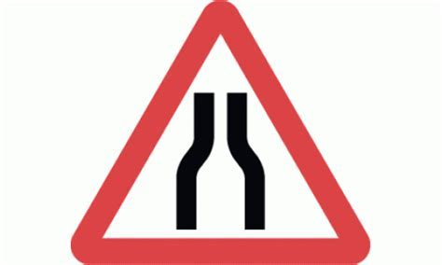 |  | Road narrows slightly at bridges. Be aware of oncoming traffic. | 11.36
7.3 | 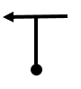 |  | Turn left signed Newent B4215 | 11.68
10.8 |  |  | Turn right signed Ross-on-Wye B4221 and M50 | 17.28
12.5 | 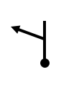 |  | Turn left signed Aston Ingham, Mitcheldean and Lea B4222 | 20.0
14.8 |  |  | Turn sharp right signed Aston Crews | 23.68
A 14.9 |  |  | Blind bend to left that narrows. Slow down. | 23.84
16.0 |  |  | Turn right and immediately left to go straight across signed Mitcheldean | 25.6
A 16.2 |  |  | Road Narrows for 200 yards | 25.92
16.4 |  |  | Turn left signed Mitcheldean and Drybrook B4224 | 26.24
17.8 |  |  | At the roundabout, take the 1st exit | 28.48
18.0 |  |  | Turn right to Mitcheldean B4224 | 28.8
18.6 |  |  | At the mini roundabout, take the 2nd exit signed Monmouth and Cinderford A4136 | 29.76
20.8 |  |  | At the traffic lights, turn right signed Drybrook and Ruardean | 33.28
24.4 |  |  | Turn right onto B4234 signed Kerne Bridge, Walford and Ross | 39.04
25.9 | 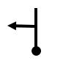 |  | Turn left signed Monmouth, Symonds Yat and Goodrich B4229 | 41.44
28.0 |  |  | Turn right signed Whitchurch, Symonds Yat West, East and Peregrine Path | 44.8
28.1 |  |  | Turn right signed Hereford A4137 | 44.96
32.0 |  |  | Turn left signed Skenfrith and Abergavenny B4521 | 51.2
47.9 |  |  | Turn left into first car park or 2nd left for overflow. If you have a National Trust membership. Please park in the car park to the right. | 76.64
0.0 |  |  | Turn right out of National Trust Car Park or Left out of the Copper Kettle Tea Room. Reset trip at entrance of National Trust Car Park. | 0.0
1.3 |  |  | Turn Right signed Hereford A465 and Abergavenny A40 | 2.08
1.4 |  |  | Take the slip lane left Signed Abergavenny Y-Fenni A465 and Hereford avoiding low bridge osgol pont isel A40 | 2.24
A 3.2 |  |  | This next junction is complicated. Treat it as a roundabout. Keep left, stay in the left lane and take the first exist signed Usk Brynbuga B4598. | 5.12
6.7 |  |  | Turn right signed Usk B4598 | 10.72
13.0 |  |  | Turn left onto the Usk high street signed Newport and Monmouth | 20.8
14.2 |  |  | Turn left signed Chepstow. It is also labelled on the road | 22.72
14.2 |  |  | Turn left signed Chepstow, Gwernesney and Llandenny | 22.72
26.1 |  |  | Turn left signed Tintern, Monmouth A466 and Chepstow B4239 | 41.76
26.2 | 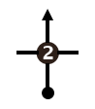 |  | At the roundabout, take the 2nd exit signed Tintern and Monmouth A466 | 41.92
26.4 |  |  | At the roundabout, move into the right lane and take the 2nd exit signed A466 | 42.24
41.2 | 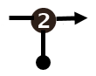 |  | At the roundabout, take the 2nd exit signed Forest of Dean and Mitcheldean A4136 | 65.92
41.2 |  |  | At the roundabout, take the 2nd exit signed Forest of Dean and Mitcheldean | 65.92
46.1 |  |  | Turn Left signed Symonds Yat, English Bicknor and Christchurch | 73.76
46.7 |  |  | Turn Left signed Hillersand, Symonds Yat Rock and Symonds Yat East. | 74.72
48.5 |  |  | Turn Left into Parking. | 77.6

