
Myles and Rowan’s Autumn Dash
Date: Sunday 20th October 2024
Start: Ross Services, HR9 7QJ
Time: 9:30 meeting time for coffees and breakfast rolls (Starbucks is open as well as the Asda/Burger King)
Depart: 10:30 (briefing at 10:15)
Mid Point: Ludlow Farm Shop, Bromfield, SY8 2JR (12:00)
Finish: The Running Horse Inn, Bewdley, DY12 2QP (around 15:00)
Miles | Direction | Instructions | Km
0.0 |  | Zero Trip on exit of slip road out of Ross Services and move into the right lane | 0.0
0.1 |  | At roundabout make a u-turn, 5th exit, onto A449 (North) | 0.16
0.6 |  | At roundabout turn left, 1st exit, onto A449 to Ledbury | 0.96
2.4 | 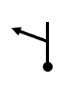 | Turn left at the fork, onto B4225 (no signpost) | 3.86
2.7 |  | At junction, turn left onto B4224, towards Hereford | 4.34
4.5 | 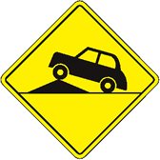 | Caution! Uneaven Road Surface / Potholes | 7.24
7.8 | 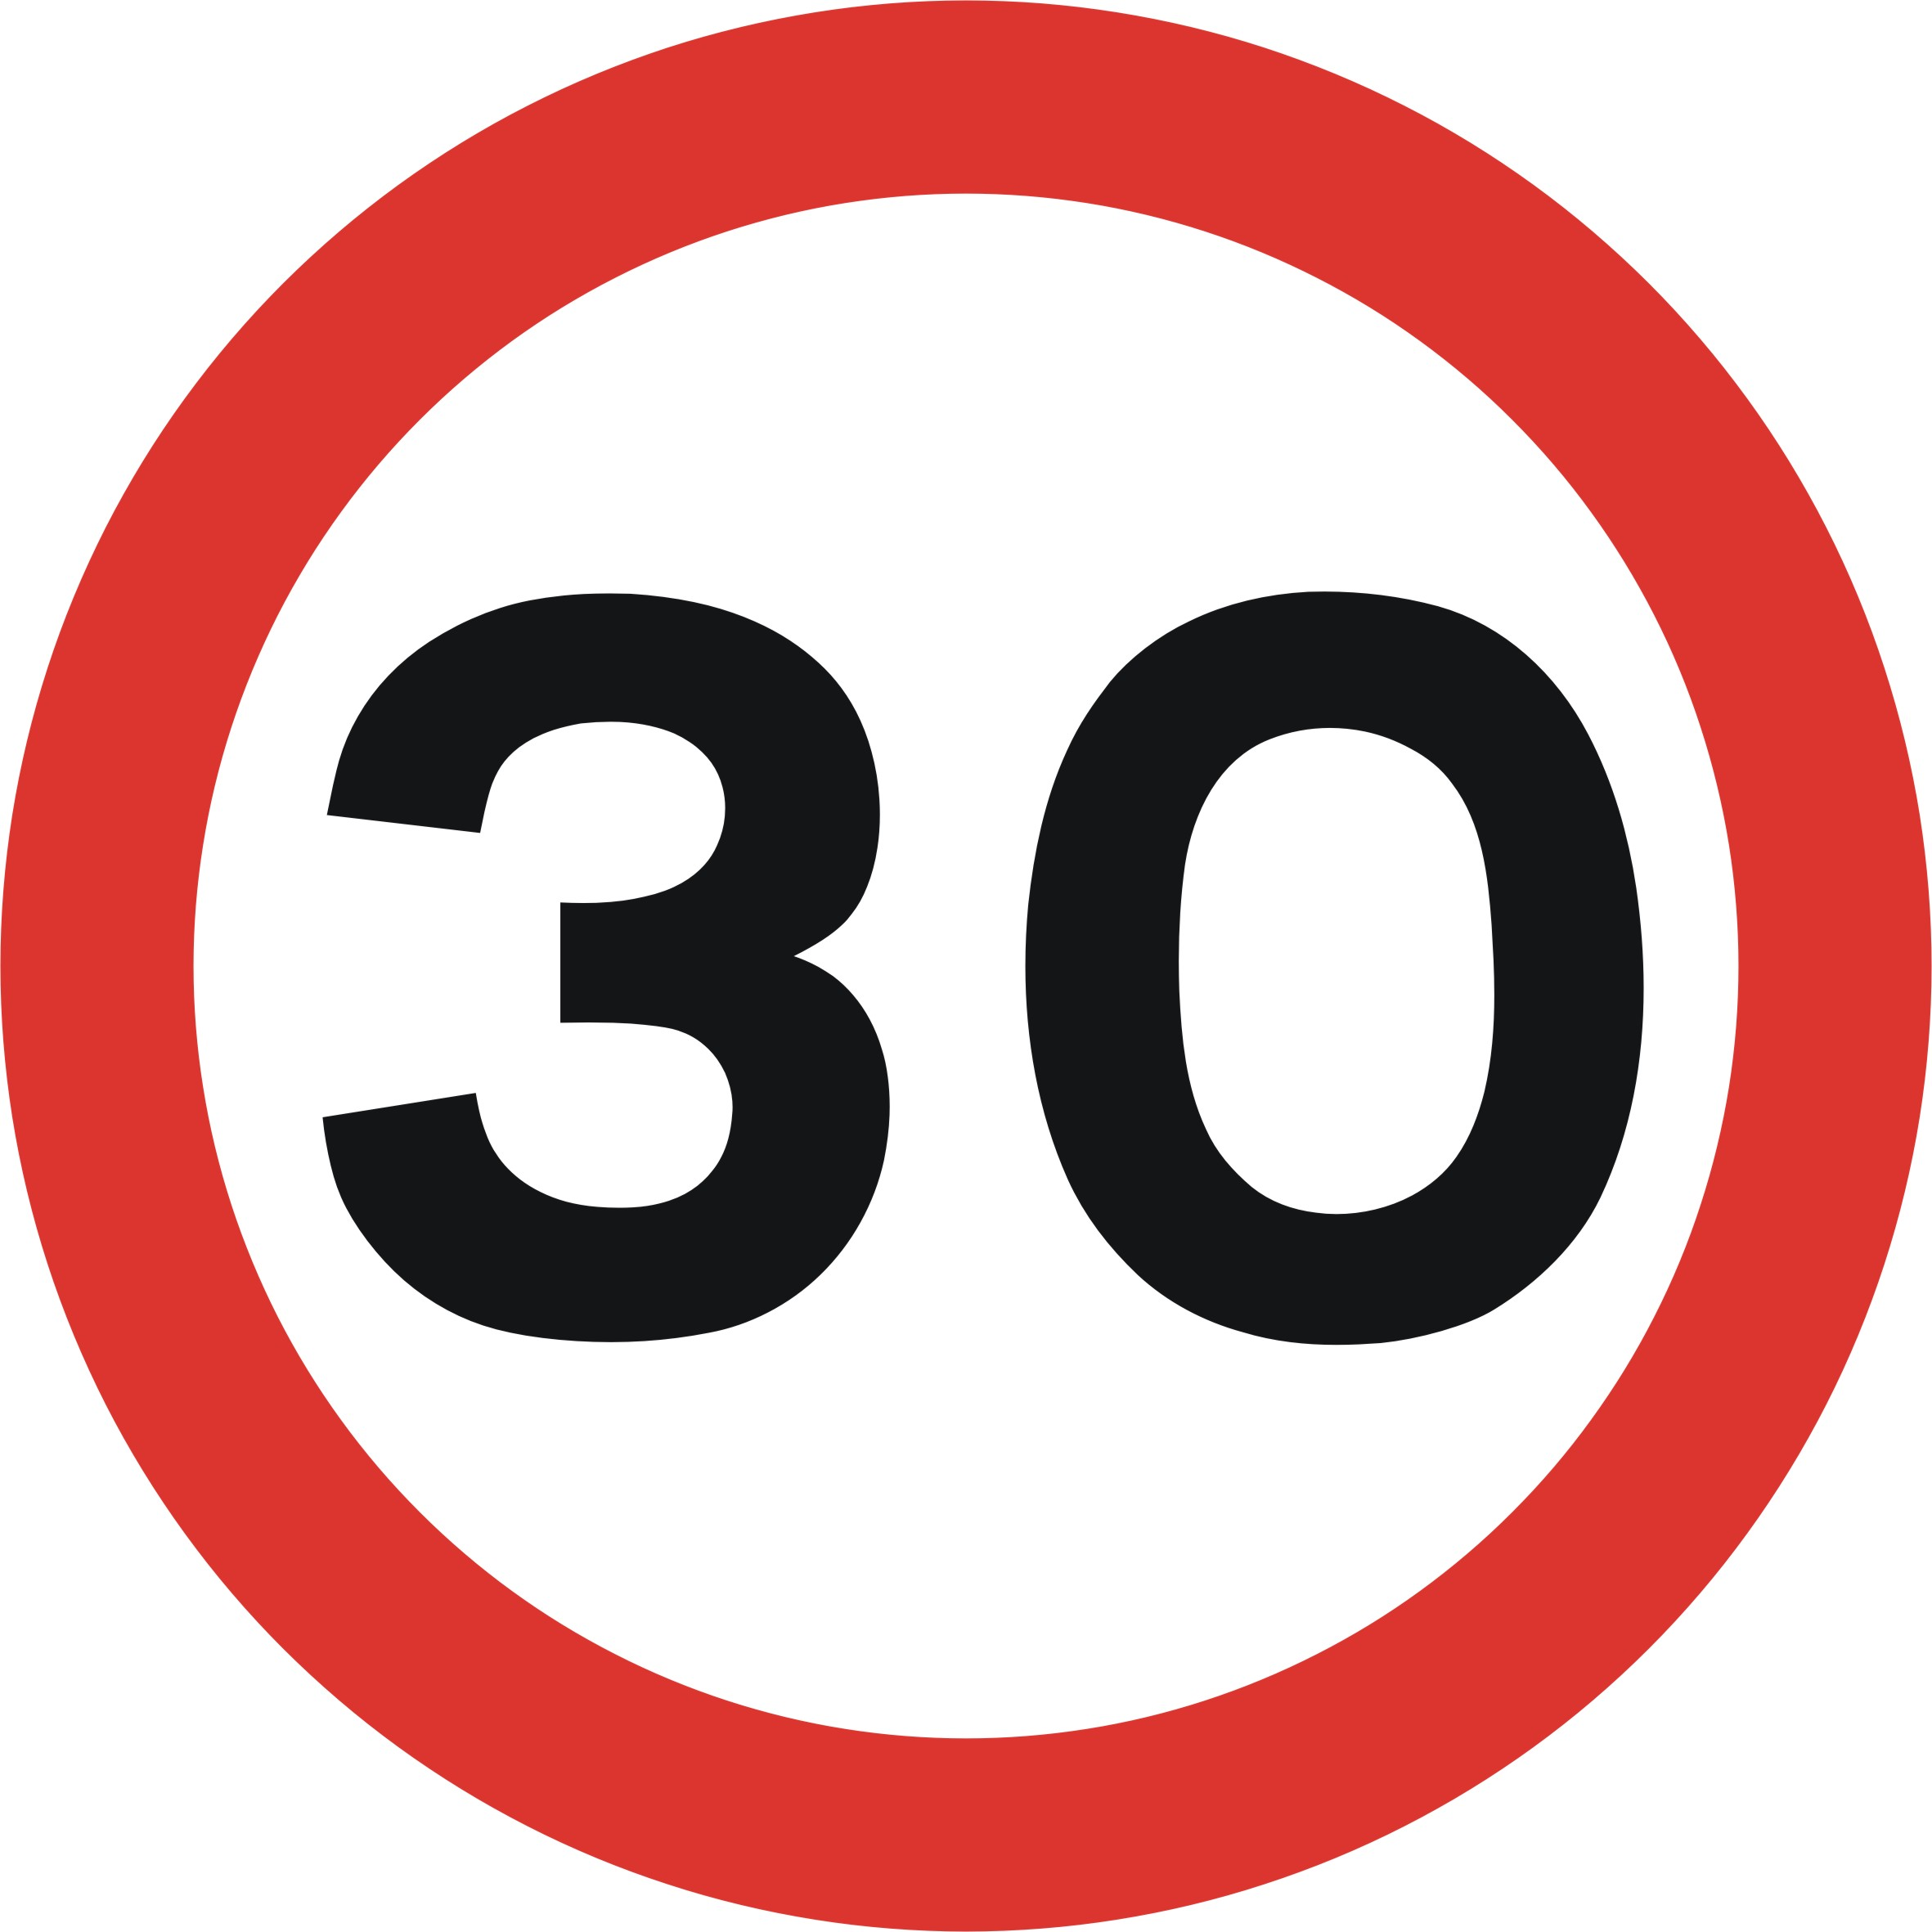 | Fownhope, 30 MPH Speed Limit | 12.55
9.9 |  | Mordford, 30 MPH Speed Limit | 15.93
10.1 |  | Turn Right, small sign to Dormington just after the Moon Inn | 16.25
12.3 |  | Turn Right, towards Ledbury (A438) | 19.79
13.5 |  | Turn left at Crossroads towards Yarkhill  (Caution: This is easy to miss as the sign is overgrown!) | 21.72
14.8 |  | At the T-Junction, Turn Right, onto A4103 | 23.81
16.9 | 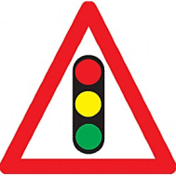 | Continue straight on the A4103 at traffic lights | 27.19
20.3 |  | Turn left onto B4214, towards Bromyard | 32.66
20.7 |  | Caution! Road Narrows | 33.31
21.1 |  | Bishops Frome, 30 MPH Speed Limit | 33.95
22.7 |  | Caution! Large potholes! | 36.53
24.9 |  | Turn Right onto A465, towards Bromyard and Tenbury  (Caution: Bad road surface) | 40.07
25.3 |  | Bromyard, 30 MPH Speed Limit | 40.71
25.7 |  | Turn Right at the T-Junction onto the A44 towards Worcester | 41.36
25.8 |  | Bear left onto B4214, towards Tenbury/Town Centre and continue straight at Give Way sign | 41.52
26.0 | 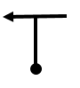 | Turn Left, onto High Street | 41.84
26.1 |  | Turn Left and then turn immediate right towards Tenbury (B4214) | 42.00
27.2 |  | Caution! Bad Road Surface! | 43.77
28.5 |  | Edwyn Ralph, 30 MPH Speed Limit | 45.86
36.8 |  | Turn Right at the T junction onto A4112, Signpost Kidderminster (A456) | 59.22
37.1 |  | Continue Left on A4112, towards Kidderminster | 57.70
37.3 |  | Turn Left onto the A456, towards Shrewsbury and Leominster | 60.02
37.5 |  | Turn Right, onto the B4214 towards Clee Hill | 60.35
39.4 |  | Caution! Potholes! | 63.40
41.1 |  | Knowle 30 MPH Speed Limit | 66.14
41.9 |  | Clee Hill 30 MPH Speed Limit | 67.43
42.2 |  | Turn Left onto A4117, towards Ludlow | 67.91
46.9 | 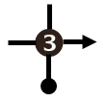 | At the roundabout, 3rd Exit, onto the A49 | 75.47
49.8 |  | Turn Right into the Ludlow Farm Shop then turn immediate right and follow the road round to the main carpark. | 80.14

End of First Half of Drive – Rest stop is planned here for 1 and a half hours with expected time of departure between 13:30-14:00

Part 2 – Ludlow to Bewdley

Miles | Direction | Instructions | Km
0.0 |  | **Zero Trip**  Left turn onto A49 | 0.0
0.8 | 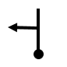 | Turn left onto B4365, towards Bridgenorth | 1.28
5.6 |  | Turn right onto B4368, towards Much Wenlock | 9.01
6.7 |  | Diddlesbury 30 MPH Speed Limit | 10.78
7.7 |  | Aston Munslow 30 MPH Speed Limit | 12.39
8.5 |  | Munslow 30 MPH Speed Limit | 13.67
10.1 | 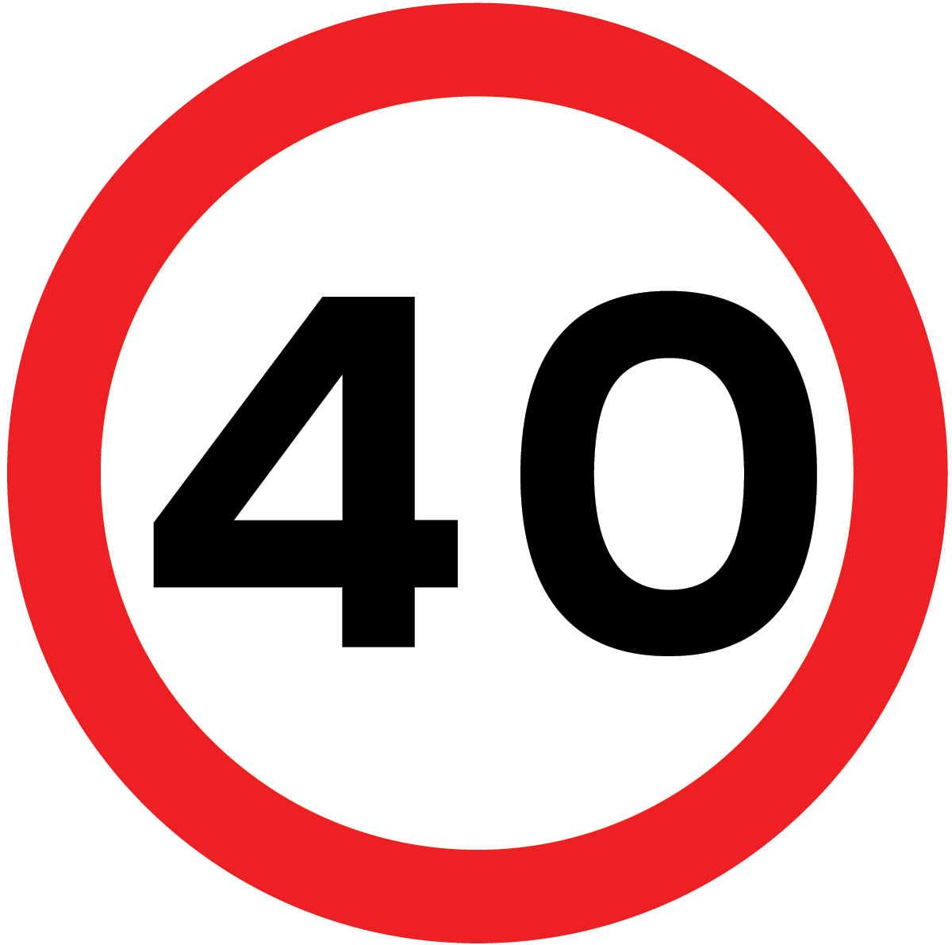   | Caution! Hungerford 40 MPH Limit  (Speed van area) | 16.25
12.2 |  | Turn Left onto B4378, toward Much Wenlock | 19.63
12.4 |  | Shipton 40 MPH Speed Limit | 19.95
14.0 |  | Brockton 30 MPH Speed Limit | 22.53
16.0 |  | Boughton 30 MPH Speed Limit | 25.74
18.6 |  | Much Wenlock 30 MPH Speed Limit | 29.93
18.9 |  | Turn Right onto A458, towards Bridgenorth | 30.41
23.7 |  | Moreville 30 Speed Limit | 38.14
24.1 |  | Turn Right, towards Highley, Kinlet and Cleobury Mortimer | 38.75
24.3 |  | Caution! Large Potholes | 39.10
26.0 |  | Turn Left then Turn Right, towards Kinlet and Cleobury Mortimer | 41.84
26.8 |  | Turn Right onto B4363, toward Cleobury Mortimer | 43.13
27.2 |  | Caution! Narrow bridge, Give way to oncoming vehicles | 43.77
34.5 |  | Kinlet 30 MPH Speed Limit | 55.52
37.7 |  | Turn left onto B4201 towards Bewdley | 60.67
37.8 |  | Caution! Potholes on road! | 60.83
38.6 |  | Turn Left onto A4117 towards Bewdley | 62.12
41.4 |  | Far forest 30 limit | 66.62
42.0 |  | Callow Hill 30 limit | 67.59
42.1 |  | Turn Left onto A456 towards Bewdley | 67.75
44.0 |  | Turn Right into the Running Horse Inn | 70.81

End of Part 2! We hope you enjoyed our drive! :)

