Sunday 24TH September 2023
Start: Croome Court WR8 9AZ
Time: 10:00am for breakfast /coffee
Depart: 10:45 (11:00 latest)
Coffee : Evesham Garden Centre, The Valley, Evesham WR11 4DS
Finish: The Cotswold Barn, A424, Moreton in Marsh, GL56 0QZ.
Miles | Direction | Instructions | Km
0.0 | 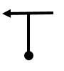 | Turn left out of Croome Entrance. | 0.0
0.03 | 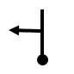 | Turn left for Kinnersley. | 0.0
1.2 |  | Turn Left and follow signs for Kinnersley and Earl’s Croome. | 1.9
2.9 |  | Turn left and follow signs for Dunstall Common. | 4.7
3.9 | 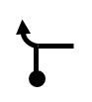 | Turn left onto A4104 signed Pershore. | 6.3
6.2 |  | Turn Right onto Eckington Road signed Tewkesbury and Cheltenham (B4080).  Follow this road over Eckington Bridge, through Eckington and on to Bredon. | 10.0
10.7 |  | In Bredon, at ‘T’ junction turn Left signed Cheltenham B4079.  Follow this road towards Kemerton, going past Bredon Village Hall and Surgery. Ignore the right turn to Cheltenham.  Continue through Kemerton, Overbury, Conderton, sharp right by the Yew Tree  Continue to Beckford, | 17.2
14.6 | 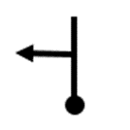 | Turn left as road bears right signed Beckford Silk ( Ashton Road)  Follow this road through Ashton Under Hill to Elmley Castle | 23.5
20.0 |  | Entering Elmley Castle follow the road through, turn right onto Main Street (Queen Elizabeth pub opposite, no sign). Be aware this is a narrow section.  Follow the road left and pass through Little Comberton | 32.2
23.3 |  | Go right onto the B4084 signed Evesham | 37.5
27.9 | 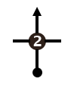 | Take the 2nd exit at the roundabout | 44.9
28.6 |  | At the traffic lights in Evesham turn left signed Evesham town centre. | 46.0
29.0 |  | Take the 2nd exit at the roundabout, then continue straight through the traffic lights and crossings. | 46.7
30.6 | 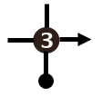 | Take the 3rd exit at the roundabout onto the A44. | 49.2
30.7 |  | Keep in the right-hand lane & take the 2nd exit at the roundabout. Then take the exit to the services/The Valley Shopping centre/Evesham country park. | 49.4
Leg 2
0.0 |  | Return to the roundabout. Zero your trip and take the 3rd exit signed A46N. | 0.0
4.3 |  | Take the 3rd exit onto the B439 signed Bidford on Avon | 6.9
5.4 |  | Take the 2nd exit B439 | 8.7
8.6 |  | Take right turn signed Welford On Avon | 13.8
14.2 |  | Take right turn onto the B4632 | 22.9
14.7 |  | Take the 2nd exit Mickleton | 23.7
15.3 |  | Take the 2nd exit signed Broadway B4632.  Continue through Weston Sub Edge and Saintbury | 24.6
19.5 |  | Take the 1st exit at the roundabout then continue through Willersley | 31.4
20.5 | 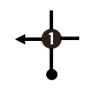 | Take the 1st exit at the roundabout onto A44 signed Broadway Tower  Enjoy Fish Hill. | 33.0
25.8 | 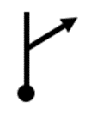 | Take the right turn on to A424 signed Stow on the Wold | 41.5
28.2 | 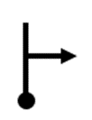 | The Cotswold Barn will be on your right – plenty of car parking and excellent café. You have reached your destination. | 45.4

