
The Shakespeare Country Drive
Date: Sunday 22nd September 2024
Start: The Queen Elizabeth Inn, Main Street, Elmley Castle, Nr Pershore WR10 3HS (dog friendly) NOTE WE ARE PARKING ON THE STREET NOT IN THE PUB CAR PARK (see diagram at end of instructions)
Time: 9:30 for breakfast / coffee / cake
Briefing: 10:30
Depart: 10:45
Coffee / Cake / Lunch: Charlecote Garden Centre, Charlecote, Warwickshire, CV35 9ER (arrive 13:00 to 13:15). NOTE WE ARE PARKING IN THE NATIONAL TRUST CAR PARK NEXT DOOR, NOT THE GARDEN CENTRE (see diagram at end of instructions)
Finish: Charlecote Park (National Trust), Charlecote, Warwickshire, CV35 9ER. This is across the road from Charlecote Garden Centre.

Miles | Direction | Instructions | Km
0.0 |  | ZERO TRIP, AT MAIN STREET AND THE JUNCTION WITH ELMLEY ROAD (OPPOSITE THE QUEEN ELIZABETH PUB)  Proceed straight down Elmley Road which is directly opposite the pub (first part is very narrow, beware of cyclists) | 0.0
1.9 |  | Blind Summit | 3.0
2.7 |  | Enter Aston Under Hill CAUTION! - 30MPH | 4.3
3.4 |  | TURN LEFT onto The Groaten | 5.4
4.1 |  | TURN LEFT onto A46 | 6.6
4.7 |  | TURN RIGHT onto Cheltenham Road, signposted Sedgeberrow / Winchcombe B4078) | 7.5
4.9 |  | Enter Sedgeberrow | 7.8
5.4 |  | TURN RIGHT onto Winchcombe Road B4078  CAUTION! - 30MPH | 8.6
7.1 |  | TURN LEFT on to Main Street towards Wormington  CAUTION! The signpost for this turning is covered by foliage and is easily missed! | 11.4
7.6 |  | Enter Wormington CAUTION! - 30MPH  Bear left at triangle towards Aston Somerville / Broadway | 12.3
9.5 |  | Go under railway bridge | 15.3
9.8 |  | TURN LEFT onto Cheltenham Road signposted B4632 / Broadway | 15.7
11.3 |  | Enter Broadway CAUTION! - 30MPH | 18.5
11.6 |  | TURN RIGHT onto Lower Green signposted Snowhill Manor and continue through Broadway Village Centre | 18.8
12.2 |  | At roundabout take 1ST EXIT onto Leamington Road | 19.6
12.9 |  | At roundabout take 3RD EXIT onto A44 Fish Hill, signposted Oxford A44 / Broadway Tower | 21.0
15.2 |  | TURN LEFT onto Buckle Street, signposted Saintbury | 24.4
16.0 |  | TURN LEFT to stay on Buckle Street onto Saintbury / Willersey | 25.7
16.6 |  | Enter Saintbury CAUTION! - 30MPH | 26.9
17.6 |  | TURN RIGHT onto B4632 towards Stratford | 28.3
18.2 |  | TURN LEFT to stay on Buckle Street, signposted Honeybourne Industrial Estates / Station | 29.2
18.6 |  | At crossroads continue STRAIGHT OVER onto Honeybourne Road | 30.0
20.0 |  | Enter Honeybourne CAUTION! - 30MPH | 33.0
20.7 |  | Traffic lights at bridge | 33.3
21.6 |  | Enter Ullington | 34.7
23.4 |  | Enter Bickmarsh | 37.6
24.6 |  | TURN RIGHT onto Welford Road, signposted Welford on Avon / Barton | 39.6
24.7 |  | Enter Barton CAUTION! - 30MPH | 40.0
27.0 |  | Enter Welford upon Avon CAUTION! - 30MPH | 43.6
27.7 |  | TURN RIGHT onto Long Marston Road | 44.6
29.3 |  | Enter Long Marston CAUTION! - 30MPH | 46.8
31.5 |  | CAUTION! This stretch of road is very uneven! TAKE CARE! | 50.6
32.2 |  | Turn right on B4632 towards Cheltenham | 51.8
32.7 |  | Enter Mickleton CAUTION! - 30MPH | 52.6
32.8 |  | At roundabout take 1ST EXIT onto Granbrook Lane towards Ilmington | 52.9
36.1 |  | Enter Ilmington CAUTION! - 30MPH | 58.1
36.5 |  | TURN RIGHT onto Front Street | 58.7
36.51 |  | TURN 1st LEFT onto Armscote Road | 58.8
36.7 |  | TURN 2nd RIGHT onto Darlingscott Road, signposted Darlingscott / Shipston | 59.2
37.7 |  | CAUTION! This stretch of road is very uneven! TAKE CARE! | 60.6
38.1 |  | Enter Darlingscott CAUTION! - 30MPH | 61.5
39.0 |  | At crossroads continue STRAIGHT OVER the A429 onto Darlingscott Road, towards Shipston Industrial Estate | 62.9
39.8 |  | Enter Shipston on Stour CAUTION! - 30MPH and speed bumps! | 64.0
40.2 |  | TURN RIGHT onto Campden Road B4035 signposted Evesham | 64.6
40.3 |  | TURN FIRST LEFT onto Hanson Avenue follow road all the way around until you reach London Road (Hanson Ave becomes Banister Way then Furze Hill Road but you would never guess that!) | 64.7
41.1 |  | At the T Junction TURN RIGHT onto London Road A3400
43.5 |  | TURN LEFT towards Cherington, signposted Cherington, Sutton, Stourton, Sutton-under-Brailes, Brailes | 69.7
45.0 |  | Enter Cherington CAUTION! - 30MPH | 72.0
46.3 |  | Enter Sutton-under-Brailes CAUTION! - 30MPH | 74.1
46.5 |  | TURN RIGHT onto Sutton Lane towards Brailes / Banbury | 74.3
47.6 |  | Enter Lower Brailes CAUTION! - 30MPH | 76.2
47.7 |  | TURN LEFT onto High Street B4035 signposted Shipston | 76.4
47.8 |  | Enter Upper Brailes CAUTION! - 30MPH | 76.6
47.9 |  | TURN RIGHT onto Castle Hill Lane towards Tysoe. Keep following signs towards Tysoe | 76.7
51.7 |  | Enter Upper Tysoe CAUTION! - 30MPH | 82.8
54.5 |  | At crossroads continue STRAIGHT OVER the A422 | 87.2
56.5 |  | Enter Little Kineton CAUTION! - 30MPH | 90.6
56.8 |  | TURN RIGHT onto Bridge Street towards Kineton | 91.0
57.0 |  | Enter Kineton CAUTION! - 30MPH | 91.4
57.2 |  | TURN LEFT onto Warwick Road B4086 signposted Wellesbourne | 91.7
57.4 |  | CAUTION! - speed bumps! | 92.0
58.9 |  | Go past Compton Verney | 94.4
59.5 |  | At roundabout take 2ND EXIT onto B4086 signposted Wellesbourne / Stratford | 95.4
61.2 |  | Enter Wellesbourne CAUTION! - 30MPH | 98.1
61.7 |  | BEAR LEFT onto one way system at Wellesbourne. Then BEAR RIGHT following all-through traffic sign. | 98.9
61.8 |  | BEAR LEFT onto B4086 | 99.1
62.1 |  | At roundabout take 2ND EXIT onto B4086 | 99.6
62.9 |  | Enter Charlecote CAUTION! - 30MPH | 100.9
63.0 |  | TURN LEFT onto Birmingham Road towards Stratford | 101.0
63.0 |  | TURN IMMEDIATELY LEFT into National Trust car park.  If on the day there are no spaces in the main car parks we will be sent to the overflow car park, direction below. A attendant will be on hand to direct us to this car park. | 101.0

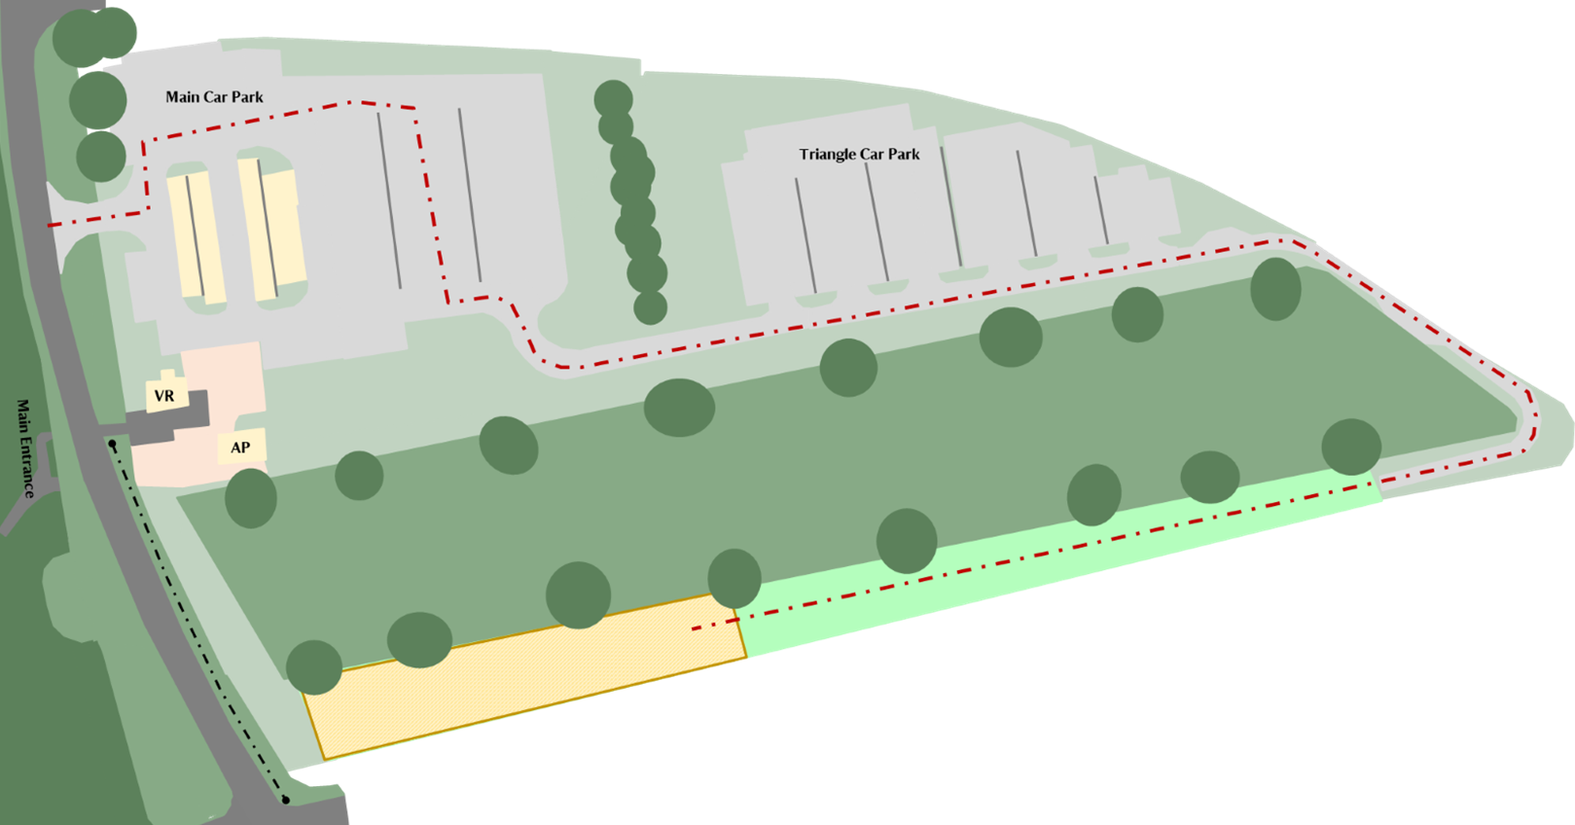

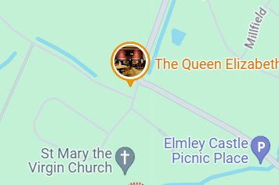

Park on road near church. HERE

